**Name: Shameer Shaik**

**Student ID: - 7007405840**

**CRN: 21627**

**GitHub link:** [**https://github.com/SHAMEERSHAIK7/Machine-Learning-CS-5710**](https://github.com/SHAMEERSHAIK7/Machine-Learning-CS-5710)

**Video link: https://vimeo.com/813054105/0c5ead8883**

**1 a)**

**1 b)**

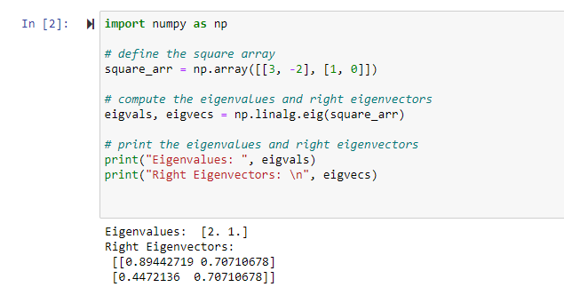

**1 c)**

**1 d)**

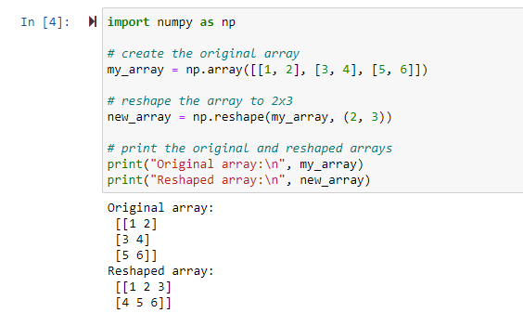

**2 )**

